**EXERCISES - CONDITIONAL LOGIC**

**Ex1.** Write a program to accepts an integer n from the user then check whether n is an even or odd number.

If n is an even number, print the following line:

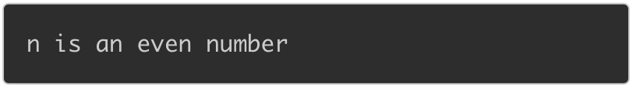

If n is an odd number, print the following line:



-----

Program:

Practicel .c 
#include<stdio.h> 
1 
2 
3 
4 
5 
6 
int main 
return 
o; 

**EX2.** Write a program that accepts an integer n from the user then checks the following conditions:

If n is a positive integer, print the following line on the screen:

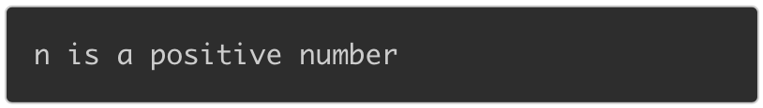

If n is a negative integer, print the following line on the screen:

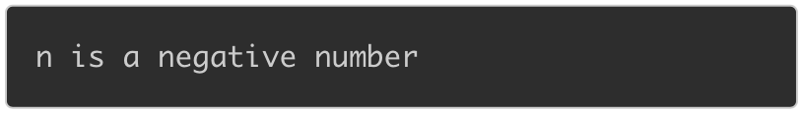

If n is equal to 0, print the following line on the screen:

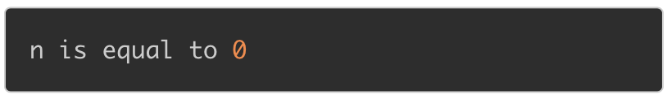

-----

Program:

Practice2.c 
1 
2 
3 
4 
5 
6 
#include<stdio.h> 
int main 
return 
o; 

**EX3.** Write a program to read two integers a and b then check whether both a and b are not equal to zero or not.

If two values are not equal to 0, print the following line on the screen:

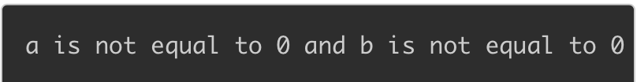

If a or b is equal to 0, print the following line on the screen:

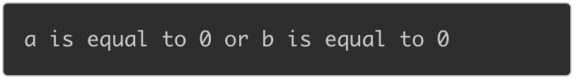

-----

Program:

Practice3,c 
1 
2 
3 
4 
5 
6 
#include<stdio.h> 
int main 
return 
o; 

**EX4.** Write a program that accepts three integers from the user and prints the biggest number among them on the screen.

For example, if you enter three numbers as below:

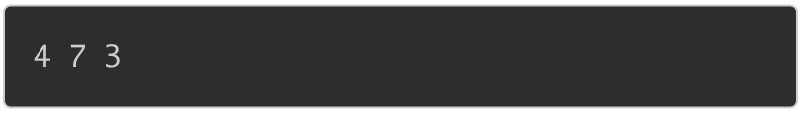

When the code is compiled and executed, it produces the following result:



If you enter:



When the code is compiled and executed, it produces the following result:



-----

Program:

Practice4.c 
1 
2 
3 
4 
5 
6 
#include<stdio.h> 
int main 
return 
o; 

**EX5.** Write a program that accept an integer a then check whether a is in the range [10, 100] or not.

If a is in the range [10, 100], print the following line on the screen:



If a is not in the range, print the following line on the screen:



where {P} is the value of a.

-----

Program:

Practice5.c 
1 
2 
3 
4 
5 
6 
#include<stdio.h> 
int main 
return 
o; 

**EX6.** Write a program that accepts the test score of a student (knowing that the valid score is greater than or equal to 0 and less than or equal to 10) and checks whether the entered score is valid or not.

If the score is valid, print the following line on the screen:



If the score is invalid, print the following line on the screen:

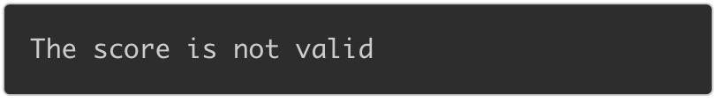

-----

Program:

Practice6.c 
1 
2 
3 
4 
5 
6 
#include<stdio.h> 
int main 
return 
o; 

**EX7.** Given 2 integer variables a and b and a character variable c knowing that c is one of 4 characters '+', '-', '*', '/'. Write a program to read 3 variables a, b and c then display the result of expression when applying the operation c on a and b.

For example, if a = 7, c = '+', b = 9, enter the following line:

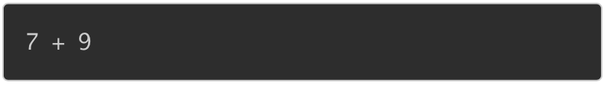

When the code is compiled and executed, it produces the following result:



-----

Program:

Practice7.c 
&a, 
3 
#include<stdio.h> 
int main 
int a, b; 
char c ; 
scanf( %c %d", 
return ê', 